Marginal Net Profit Margin % by Channel
Instead of just tracking top-line revenue, this metric determines which channels are truly profitable after subtracting ad spend, displaying it as a net margin percentage
QUERY-;

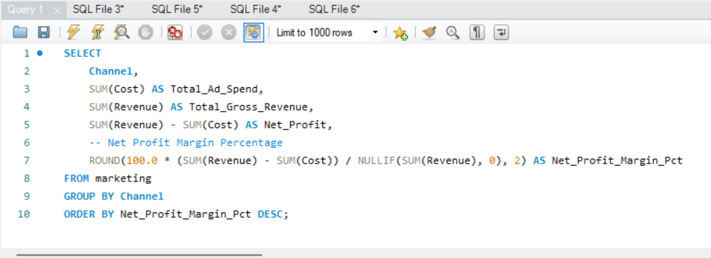

SOLUTION-;

